***MyShop, a state-of-the-art webshop***

In this exercise we'll use what we've learned in the presentation to create a state-of-the-art webshop from scratch (at least a small part of it). We also add an extra bonus and divide the solution into different projects that each handle a different layer of our application. We also use inheritance to create domain-specific repositories. So this exercise will not be 100% the same as what we have seen in presentation. But the philosophy remains of course: we use a repository to decouple the application from the way data is stored in the database.

***1. Solution Setup***

No time to waste, let's get started, open *Visual Studio* and create a new *ASP.NET Core Web Application* ***MyShop.Web*** within a solution ***MyShop*** (be sure to respect the naming of project/solution):

Choose *Model-View-Controller*, *ASP.NET Core 5.0*, and *Individual User Accounts:*

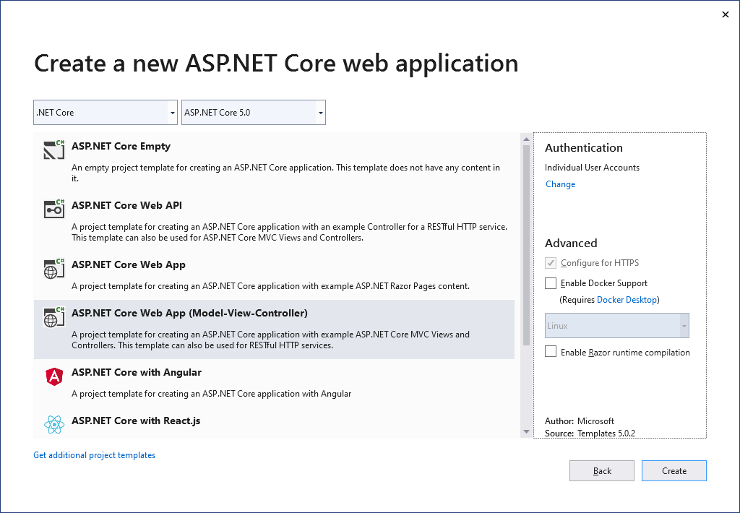

Next, add a second project to the same solution, a *.NET Core Class Library*:

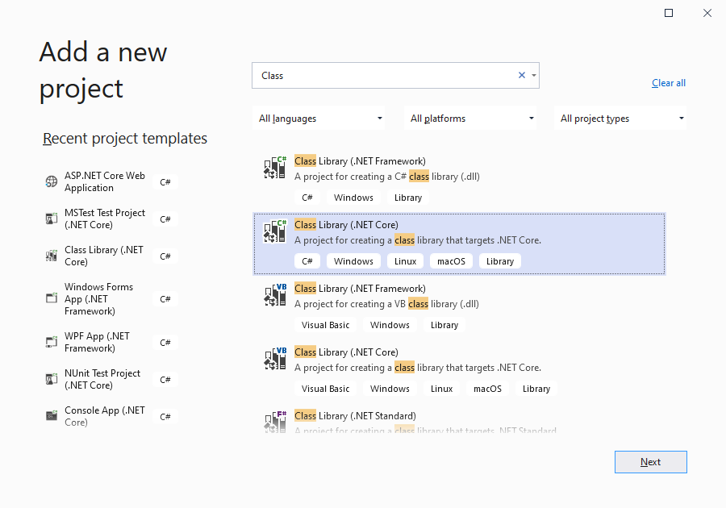

This project will contain our domain models, so we will call it ***MyShop.Domain***:

Add a third project with the name ***MyShop.Infrastructure*** to code the repositories:

Finally add a fourth project ***MyShop.Tests*** to test our webshop:

We're almost done with the first step. Delete the class *Class1.cs* in the *Domain* and *Infrastructure* projects. Add a folder ***Models*** to the *Domain* project and a folder ***Repositories*** to the *Infrastructure* project. Rename *UnitTest1.cs* in ***OrderControllerTests.cs****.* The solution now looks like this:

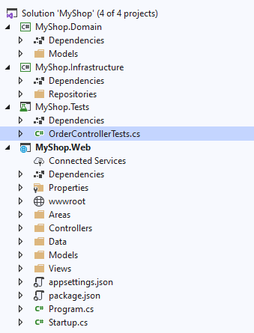

***2. Models***

Next create the domain models in the *Models* folder of the *Domain* project. For our webshop, we have customers and products. These customers will place orders, which contain multiple orderlines. Use your C#/ASP.NET knowledge to create these models:

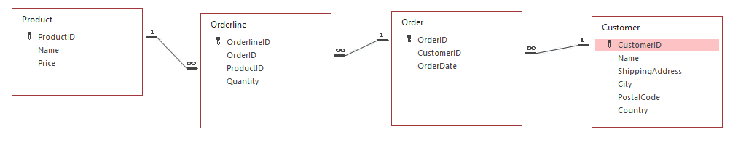

All ***ID***'s are *ints*. ***Price*** is a *decimal*, ***Quantity*** is an *int* and ***OrderDate*** is a *DateTime*. All the other fields are *strings*. Do not forget the navigation properties. Also add an extra calculated property ***OrderTotal*** to the ***Order*** model in which the total order amount is automatically calculated. This can be done using the following lambda expression:

public decimal OrderTotal => Orderlines.Sum(item => item.Product.Price * item.Quantity);

***3. Database***

Add the *ShoppingContext.cs* and *DBInitializer.cs* classes (from the *resources*) to the root of the *MyShop.Infrastructure* project. Since you are using the models from the *Domain* project, do not forget to add a reference to this project! And because we are using *Entity Framework* to communicate with our database, add the packages *Microsoft.EntityFrameworkCore.SqlServer* and *Microsoft.EntityFrameworkCore.Tools* to the *Infrastructure* project. This can be done using the *NuGet Packages Manager*. Use version *5.0.2*!

Now modify *Startup.cs* of the webshop: add the *ShoppingContext* as a service and call the *Initialize* method of the *DBInitializer* to create the database. Do not forget to add the necessary references in the *Web* project!

Start your webshop application and check if the database is created with the correct tables/data:

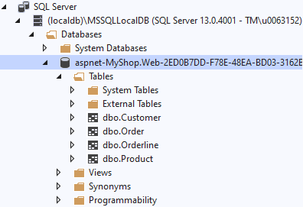

***4. Webshop***

We will not code a complete webshop of course, this would lead us too far. We only code a page which lists all the customers and orders and allows the user to add new orders. And you don't even have to write this program code yourself. You can copy the code from the ‘Resources’ on Canvas.

Add the *CustomerController.cs* en *OrderController.cs* to the *Controllers* folder of the webshop. Add the corresponding view folders (*Customer* and *Order*) to the *Views* folder. Overwrite the layout template *_Layout.cshtml* in the *Shared* folder.

For a better user experience *Vue.js* (a JavaScript framework) is used to create the new orders. *Vue.js* is beyond the scope of this course, but if you are interested, you can always take a look at the *Create* view of *Order*.

In short: all data (order, customer, lineitems) that is entered by the user ends up in a *CreateOrderModel* object. This object will be passed to the *Create* method of our *OrderController* to insert the data into our database. To make sure all of this works correctly, add the models *CreateOrderModel.cs*, *CustomerModel.cs* and *LineItemModel.cs* to the *Models* folder of your webshop.

By now, you should have a working webshop application:

in which you can retrieve all orders:

list all customers:

and add a new order to the database (using *Vue.js*):

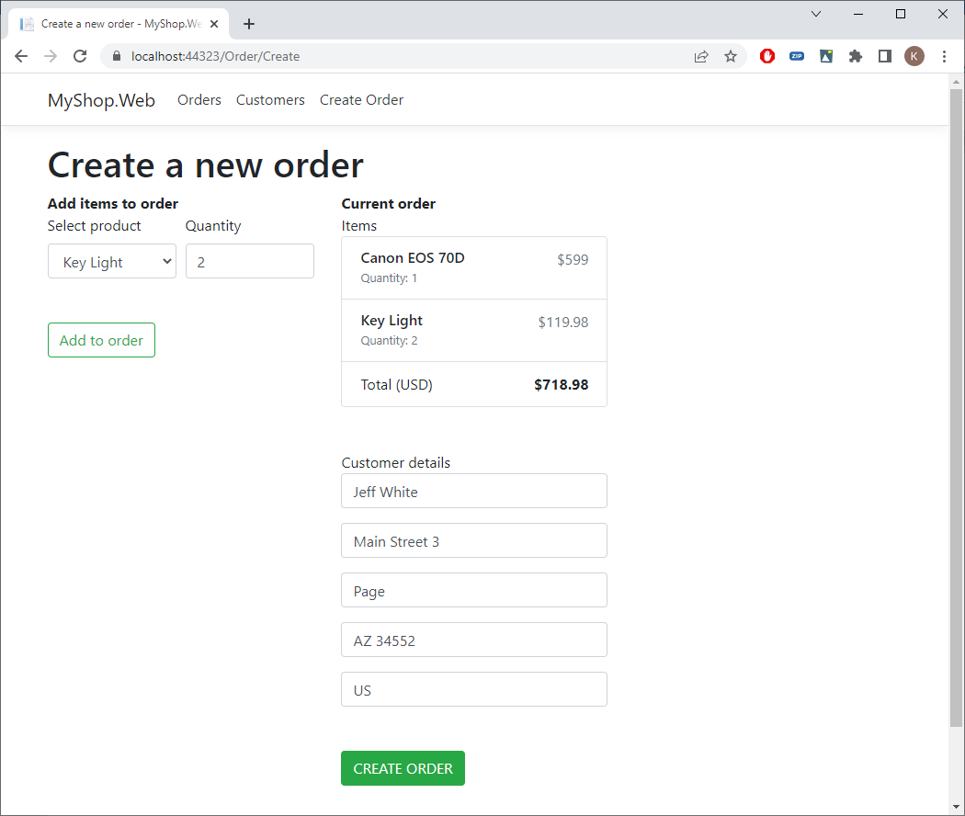

***5. Repositories***

Now apply what we've learned in the lesson to make our code reusable, maintainable and above all testable.

First in the *Repositories* folder, create an interface *IRepository.cs* with the following methods:

- *Add* gets an object as parameter and returns the inserted object

- *Update* gets an object as parameter and returns the updated object

- *Get* gets an int as parameter and returns the corresponding object

- *All* has no parameters and returns all objects

- *SaveChanges* has no parameters nor return value

Next, create an ***abstract*** class *GenericRepository* (in the *Repositories* folder) that implements this interface. We use an *abstract class* to indicate that the class is intended only to be a base class of other classes, not instantiated on its own. Mark all methods (except *SaveChanges*) as ***virtual*** to indicate they can be overridden in the derived classes.

Now we can inherit our *GenericRepository* base class to the repositories for our domain classes. Since we use inheritance, the methods will be automatically present in our derived repositories. And since the methods are virtual, they can be overridden if a different implementation is necessary.

Inherit the generic repository into three repositories (Order, Customer and Product). *Orderlines* does not have its own repository because orderlines is used as part of order.

In the constructor, call the constructor of the base class. Override the *Update* method in the derived classes to indicate what properties of the entity can be updated. Below you can find the *ProductRepository* as an example (write the code of the *OrderRepository* and *CustomerRepository* yourself). For an *Order*, the *OrderDate* and *Orderlines* can be update. And for a *Customer* the updatable fields are *Name*, *City*, *PostalCode*, *ShippingAddress* and *Country*.

using MyShop.Domain.Models;

using System.Linq;

namespace MyShop.Infrastructure.Repositories

{

public class ProductRepository : GenericRepository<Product>

{

public ProductRepository(ShoppingContext context) : base(context)

{

}

public override Product Update(Product entity)

{

var product = _context.Products

.Single(p => p.ProductID == entity.ProductID);

product.Price = entity.Price;

product.Name = entity.Name;

return base.Update(product);

}

}

}

In the *OrderRepository*, overwrite the *All* method as well and use eager loading to retrieve the *Orderlines* and *Product* information.

***6. Controllers***

We'll use dependency injection to inject our repositories into our controllers. Register the three repositories in the *ConfigureServices* method of *Startup.cs*. Use you *depency injection* knowledge!

Inject the repositories in the *CustomerController* en *OrderController*. You don't have to inject the *ShoppingContext* anymore. As a final step, use the methods of the repositories in the controllers and check if your application still works after refactoring.

***7. Testing***

First install the latest version of the *Moq* framework (version **4.16.1**) in the test project. Rename the test method in the *OrderControllerTests.cs* class in *CanCreateOrderWithCorrectModel*.

In the test try to call the *Create* method of the *OrderController* with a correct *CreateOrderModel* (containing a *CustomerModel* and a list of two *LineItemModels*). Since the repositories will be mocked, no data will be added to the database. But we can check if the *Add* method of our *OrderRepository* is called at least once. This can be done using the following statement at the end of your test:

// ASSERT

orderRepository.Verify(r => r.Add(It.IsAny<Order>()), Times.AtLeastOnce());

Hint: It will be necessary to add some project references and *usings*.

Run your test and see if it will pass!